The Degree of Difference: Predicting the Rate of Male Bachelor’s Degree Attainment, Poverty, and Marriage at the County Level
MSSP 6070: Practical Programming for Data Science
Danielle Jenkins
December 18, 2024
Executive Summary

This report provides an overview of three metrics for adult male disadvantage in counties across the United States. These metrics are the percentage of non-college educated men in a population, the poverty rate, and the marriage rate. The geographic analysis finds that the most disadvantaged men live in large states like California, Nevada, Arizona, Illinois, and Texas. The highest rates of disadvantage are in the southwest, the deep south, Wyoming, West Virginia, Appalachia, and South Dakota. Marriage rates don’t vary nearly as much across geographies. The racial subgroup analysis finds that counties with more minorities have lower educational attainment, higher poverty, and less marriage. The cluster analysis created socioeconomic clusters that mirrored the disadvantage maps. Lastly, the random forest classification models gave insight into which features have the strongest linear relationships with the disadvantage metrics. These findings give insight into next steps for further socioeconomic modelling to predict employment outcomes of disadvantaged men.

Table of Contents
Introduction 5
Data 6
Disadvantage Metrics 6
Demographic Data 7
Housing Characteristics 7
Economic Characteristics 9
Area Disadvantage Index 11
Descriptive Statistics 11
Distributions 12
Correlation 14
Geographic Perspective 15
Disadvantage Density 15
Disadvantage Severity 18
Subgroup Analysis 24
Unsupervised Predictions - County Clustering 26
Supervised Predictions – Random Forest 28
Educational Attainment 28
Poverty 31
Marriage Rate 33
Discussion 36
References 38
Appendix 40

Introduction
In the recent past, the economic prospects of men without bachelor’s degrees have been diminishing. Women are outpacing men in educational attainment. Concurrently, many of the jobs that non-college educated could rely on have been automated and outsourced. This analysis uses American Community Survey data to explore the geographic distribution of these disadvantaged men and what the economic features of their communities are. The characteristics of the counties that are being investigated as a proxy for disadvantage are the percentage of males with no bachelors degree, the percentage of men below the official poverty metric, and the percentage of men who have never been married.
This analysis will first look at the means of these features across the entire country. The next step is looking at where these men are by seeing what portion of the full disadvantaged group lives in each state. Then, counties and states will be compared to each other by their mean disadvantage in each category. After the geographic exploration, the disadvantage metrics will be aggregated for counties that have above average numbers of underrepresented ethnicities.
The counties will then be clustered using k-means clustering to find counties that are similar according to their economic and demographic features. This is an unsupervised machine learning method so there is no target variable, the goal is to generate clusters of similar counties and compare their disadvantage metrics.
Lastly, the three disadvantage metrics will be predicted using a random forest classification model. This supervised machine learning method has a target variable and will allow for the determination of which features best predict the disadvantage metrics.

Data

Disadvantage Metrics
The disadvantage metrics that are the target variable of this analysis are bachelor’s degree attainment, poverty rate, and marriage percentage. This data is from American Community Survey 2022 5-Year Estimate Tables. The subject tables of interest are “Poverty Status in the Past 12 Months by Sex by Age”, “SEX BY AGE BY EDUCATIONAL ATTAINMENT FOR THE POPULATION 18 YEARS AND OVER”, and “Sex by Marital Status for the Population 15 Years and Over”. These tables were joined and manipulated to create the variables:
- male_25_64_tot: number of males ages 25 to 64
- male_2564_less_ba: number of males who have less than a bachelor’s degree
- male_2564_less_ba_pct: percentage of males who have less than a bachelor’s degree
- pop_county_male_2554: number of males ages 25 to 54
- pop_opm_county_male_2554: number of males ages in poverty
- opm_male_2554: percentage of males ages in poverty
- pop_county_male_mar_2554: number of males who are married
- pop_county_male_never_mar_2554: number of males who never married
- pop_county_male_separated_2554: number of males who are separated
- pop_county_male_other_2554: number of males who have another marriage status
- pop_county_male_widowed_2554: number of makes who are widowed
- pop_county_male_divorced_2554: number of males who are divorced
- male_marriage_rate_2554: percentage of males who are married

Demographic Data
The demographic data used in this analysis is from the American Community Survey 2020 5-Year Estimate Tables. The specific table, “ACS DEMOGRAPHIC AND HOUSING ESTIMATES”, contributed these variables:

- MALES_COUNT
- FEMALES_COUNT
- ADULT_MALES
- ADULT_FEMALES
- GENDER_RATIO
- MALE_PERC
- FEMALE_PERC
- WHITE
- BLACK
- ASIAN
- NAT_HAW
- AM_IND
- TWO_RACE
- OTHER
- HISP_LAT
- PERC_WHITE
- PERC_BLACK
- PERC_ASIAN
- PERC_NAT_HAW
- PERC_AM_IND
- PERC_TWO_RACE
- PERC_OTHER
- PERC_HISP_LAT

Housing Characteristics
The housing characeristics data used in the machine learning modeling is from the American Community Survey 2022 5-Year Estimate Tables. The specific table, “Selected Housing Characteristics”, contributed these variables:
- HOUSING OCCUPANCY_Total housing units_Vacant housing units_Percent
- HOUSING TENURE_Owner-occupied_Percent
- HOUSING TENURE_Renter-occupied_Percent
- VEHICLES AVAILABLE_No vehicles available_Percent
- VEHICLES AVAILABLE_1 vehicle available_Percent
- VEHICLES AVAILABLE_2 vehicles available_Percent
- VEHICLES AVAILABLE_3 or more vehicles available_Percent
- SELECTED CHARACTERISTICS_Lacking complete plumbing facilities_Percent
- SELECTED CHARACTERISTICS_Lacking complete kitchen facilities_Percent
- SELECTED CHARACTERISTICS_No telephone service available_Percent
- OCCUPANTS PER ROOM_1.00 or less_Percent
- OCCUPANTS PER ROOM_1.01 to 1.50_Percent
- OCCUPANTS PER ROOM_1.51 or more_Percent
- SELECTED MONTHLY OWNER COSTS AS A PERCENTAGE OF HOUSEHOLD INCOME (SMOCAPI) !!Housing units without a mortgage
  - Less than 10
  - 10.0 to 14.9
  - 15.0 to 19.9
  - 20.0 to 24.9
  - 25.0 to 29.9
  - 30.0 to 34.9
- SELECTED MONTHLY OWNER COSTS AS A PERCENTAGE OF HOUSEHOLD INCOME (SMOCAPI) !!Housing units with a mortgage
  - Less than 10
  - 10.0 to 14.9
  - 15.0 to 19.9
  - 20.0 to 24.9
  - 25.0 to 29.9
  - 30.0 to 34.9
- GROSS RENT AS A PERCENTAGE OF HOUSEHOLD INCOME
  - 15.0 to 19.9
  - 20.0 to 24.9
  - 25.0 to 29.9
  - 30.0 to 34.9
- OCCUPANTS PER ROOM_1.51 or more_Estimate
- SELECTED MONTHLY OWNER COSTS (SMOC)_Housing units with a mortgage_Median (dollars)_Estimate
- Median_rent

Economic Characteristics
The economic characteristics data used in the machine learning modeling is from the American Community Survey 2022 5-Year Estimate Tables. The specific table, “Selected Housing Characteristics”, contributed these variables:

- Over_16
- labor_force
- employed
- unemployed
- armed_forces
- unemployment_rate
- young_children_two_income
- older_children_two_income
- commute_drive_alone
- commute_carpool
- commute_public
- commute_walked
- commute_other
- commute_wfh
- mean_travel_time
- occ_man_bus_sci_arts
- occ_service
- occ_sales_office
- occ_nat_con_maint
- occ_prod_trans_mater
- ind_ag_for_fish
- ind_construction
- ind_manufacturing
- ind_wholesale
- ind_retail
- ind_trans_warehouse_utilities
- ind_information
- ind_finance_ins_realestate
- ind_prof_sci_man_admin
- ind_ed_health_social
- ind_hospitality
- ind_other
- ind_public_admin
- class_priv_salary
- class_government
- class_self_employed
- class_unpaid_family
- median_household_income
- mean_household_income
- perc_soc_security
- mean_soc_security
- perc_retirement
- mean_retirement
- perc_ssi
- mean_ssi
- perc_cash_pub
- mean_cash_pub
- perc_snap
- male_median_earning
- female_median_earning
- per_capita_income
- insured
- private_health
- public_health
- uninsured
- poverty_all_families
- poverty_children_families
- poverty_adults

Area Disadvantage Index
The Area Disadvantage Index is a ranking developed by a team led by Amy Kind, MD, PhD the University of Wisconsin-Madison. The metric is the national or state percentile of the block groups ADI score. This ADI score quantifies the socioeconomic disadvantage of a neighborhood at the census block group. It is calculated using the American Community Survey 5-Year Estimates. This dataset was used aggregated by county to create the variables:
- ADI_STATERNK_2022
- ADI_NATRNK_2022

Descriptive Statistics

The measures of disadvantage being used in this analysis are lack of bachelor’s degree attainment, official poverty metric, and marriage rate for adult males. The mean percentage of non-college educated males in a county is 79.4% and the median is 82.1%, which indicates a left skew. The mean poverty rate is 10.8% and the median is 9.8%, which indicates a left skew. The mean marriage rate is 51.1% and the median is 52.3%, which indicates a fairly normal distribution. These distributions are visible in figures 1, 2, and 3.

Table 1
Descriptive Statistics
index | count | mean | std | min | 25% | 50% | 75% | max
male_2564_less_ba_pct | 3144.0 | 0.794 | 0.109 | 0.180 | 0.747 | 0.821 | 0.869 | 1.000
opm_male_2554 | 3144.0 | 0.108 | 0.057 | 0.000 | 0.068 | 0.098 | 0.134 | 0.538
male_marriage_rate_2554 | 3144.0 | 0.511 | 0.111 | 0.040 | 0.456 | 0.523 | 0.579 | 1.000

Distributions
Figure 1
No Bachelor’s Degree Distribution

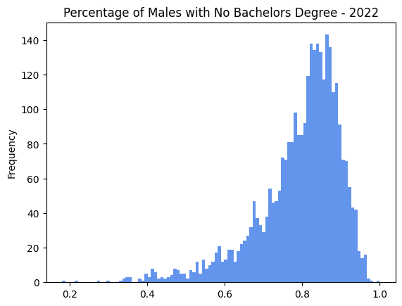
Table 2
Poverty Rate Distribution
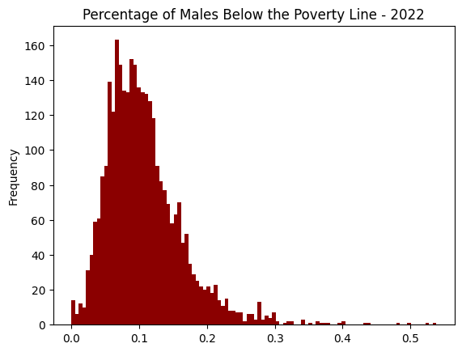
Table 3
Marriage Rate Distribution
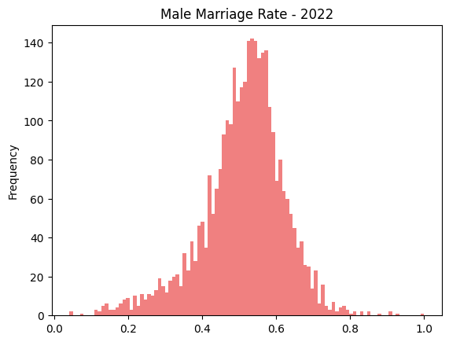

Correlation
The three disadvantage metrics do not have very strong relationships with eachother. The strongest relationship is the positive relationship between poverty rate and educational attainment, which has a 0.427 correlation coefficient.

Table 4
Correlation Matrix
index | male_2564_less_ba_pct | opm_male_2554 | male_marriage_rate_2554
male_2564_less_ba_pct | 1.000 | 0.427 | -0.281
opm_male_2554 | 0.427 | 1.000 | -0.434
male_marriage_rate_2554 | -0.281 | -0.434 | 1.000

Figure 2
Correlation Matrix Heatmap
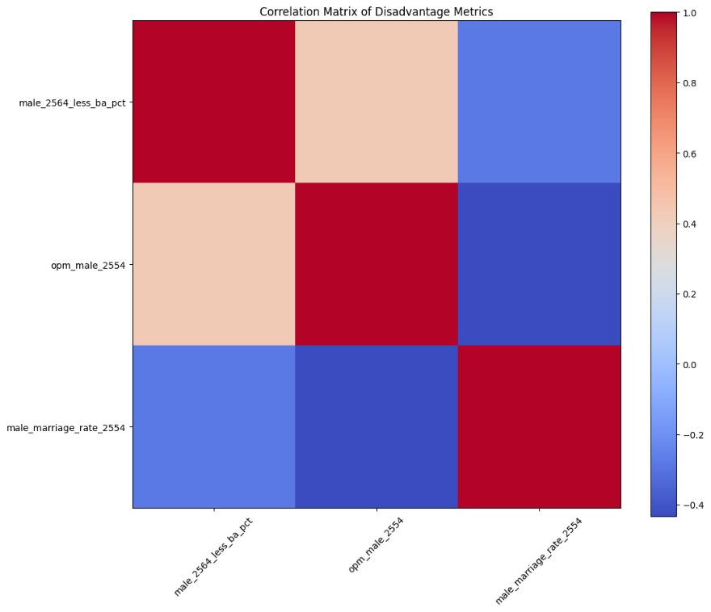

Geographic Perspective

Disadvantage Density
The first geographic question to address is regarding where these disadvantaged men are located. Some states may have severe rates of disadvantage but have small populations, while other states have low rates of disadvantage but a large number of disadvantaged people among a large population.
Map 1 shows that California, Arizona, Illinois, Nevada, and Texas have the largest number of males with no bachelor’s degree compared to other states.

Map 1
States’ Share of Males with No Bachelor’s Degree
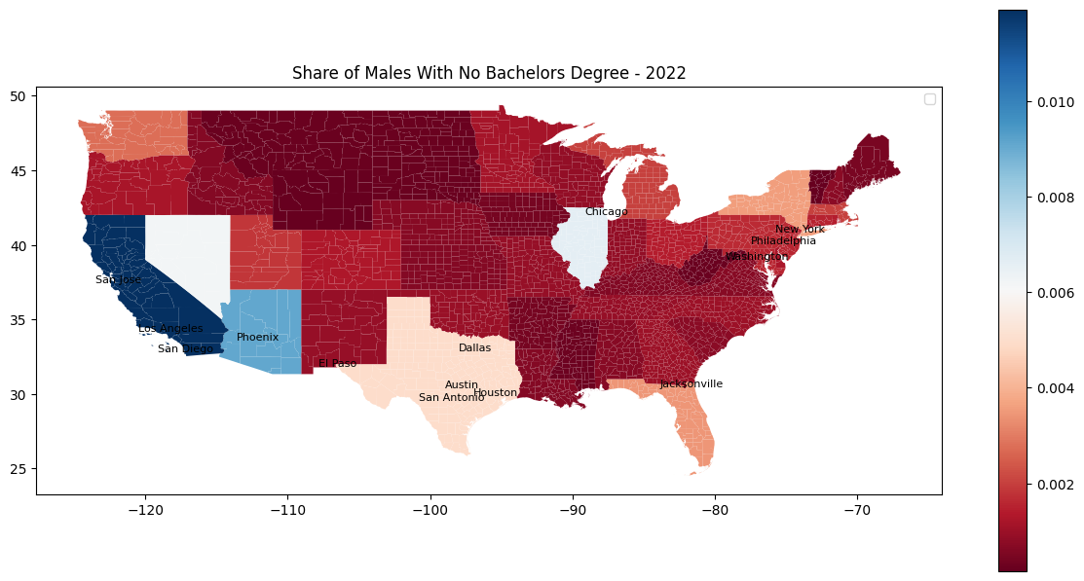

Map 2 shows that California, Arizona, Illinois, and Nevada have the largest number of males in poverty.
Map 2
States’ Share of Males in Poverty
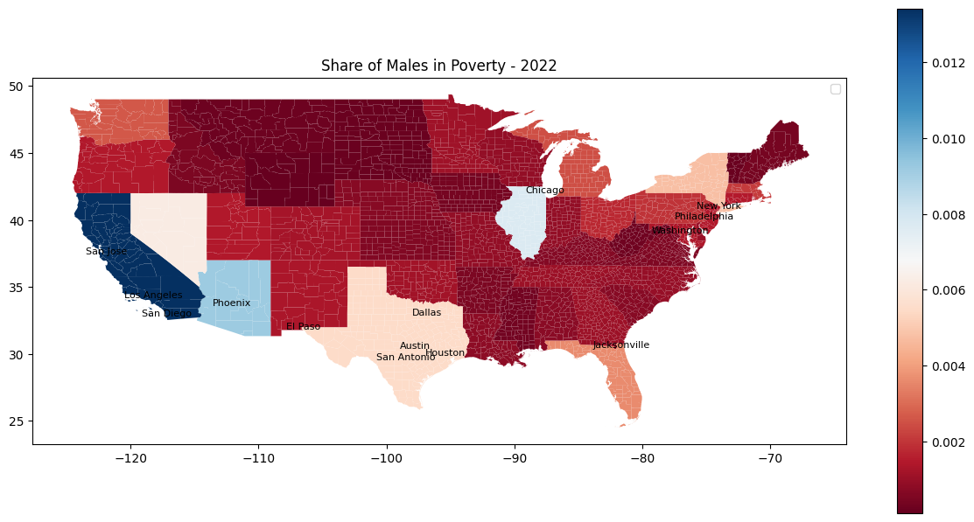
Map 2 shows that California, Arizona, Illinois, and Texas have the largest number of males in who are married

Map 3
States’ Share of Males Who are Married
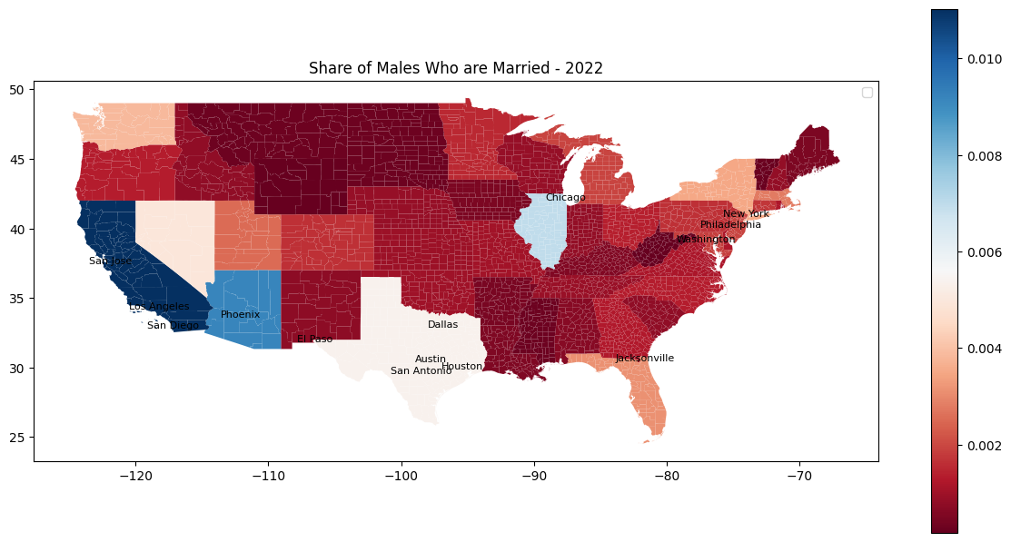

Disadvantage Severity
The next geographic question is how severe the disadvantage is in different geographic locations. The most disadvantaged areas have the highest rates of disadvantaged males.

Educational Attainment
Map 4 shows that the states with the highest percentages of non-college educated men are West Virginia, Mississippi, Nevada, and Louisiana. Massachusetts has the lowest percentage.
Map 4
Percentage with No Bachelor’s Degree by State
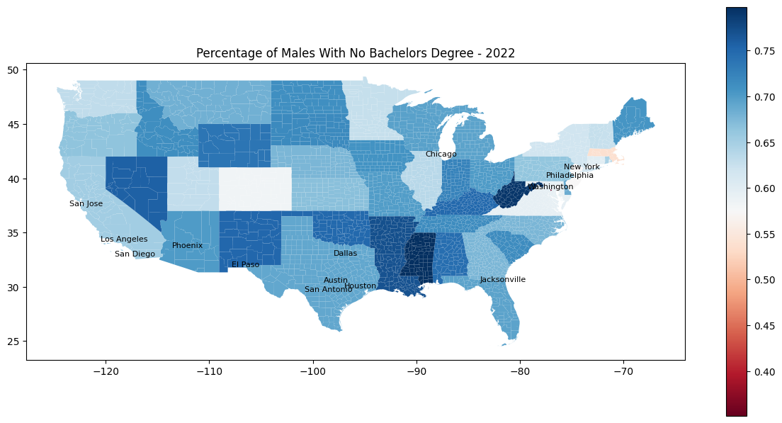
Map 5 shows that the lowest percentages of non-college educated men occur in counties surrounding cities like New York, Philadelphia, Chicago, San Jose, Seattle, Detroit, Denver, and others. The highest percentages are in southwest Texas, Nevada, New Mexico, and the Deep South.
Map 5
Percentage with No Bachelor’s Degree by County
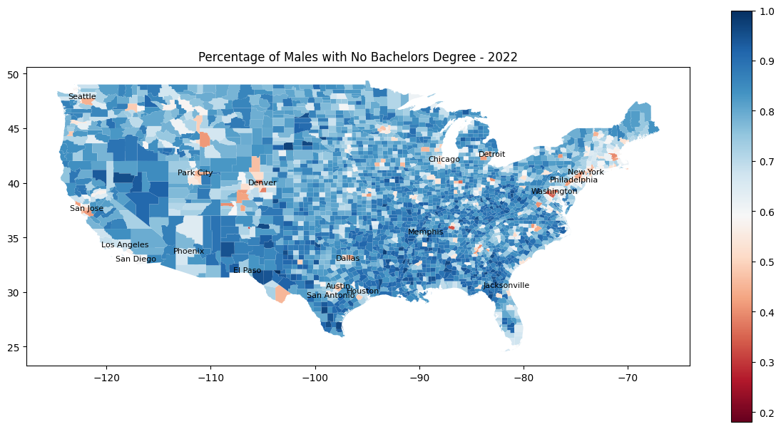

Poverty
Map 6 shows that the highest poverty states are New Mexico, West Virginia, Mississippi, and Louisiana. The lowest poverty states are New Hampshire, Utah, Maryland, and Virginia.

Map 6
Percentage in Poverty by State
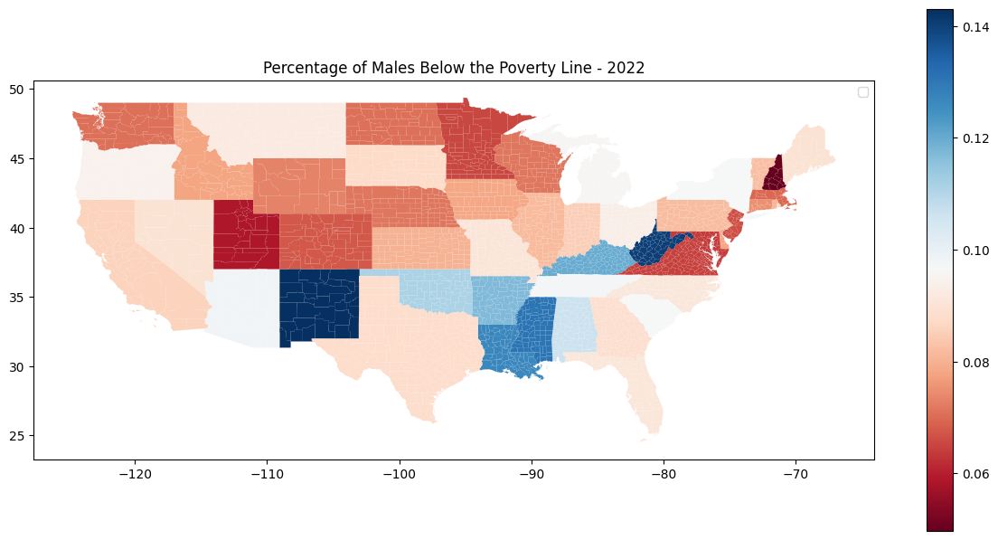
Map 7 shows that poverty is highest in counties in the Southwest, South Dakota, Louisiana, and Appalachian Region.

Map 7
Percentage in Poverty by County
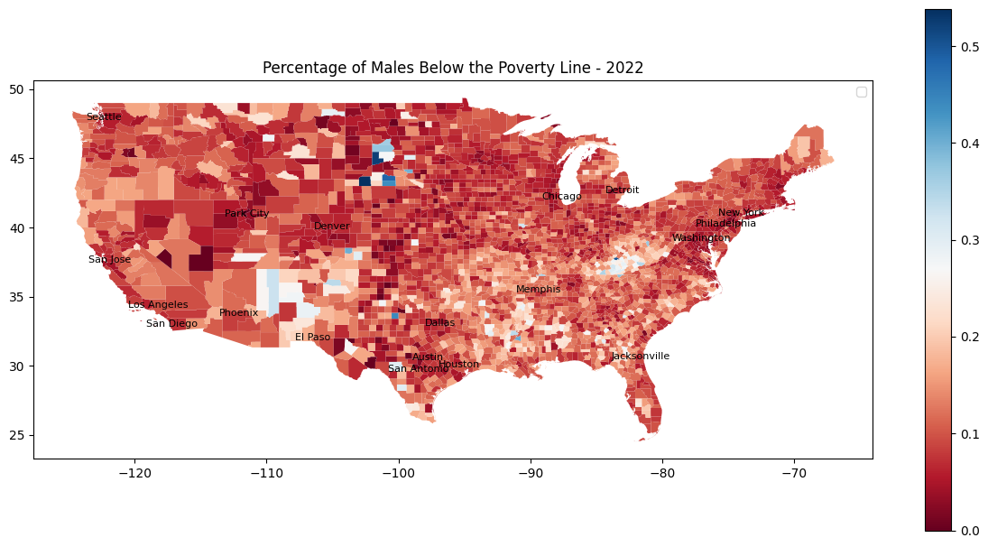Marriage
Map 8 shows that the lowest marriage rates are in Utah, Wyoming, Idaho, and Arkansas. The highest are in New York, California, New Mexico, and Wyoming.
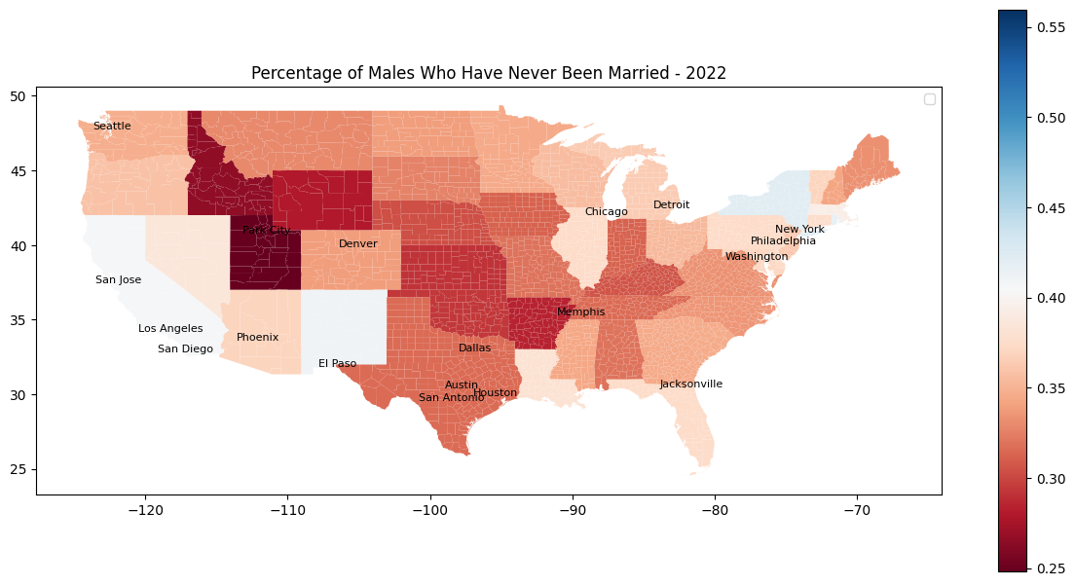
Map 8
Marriage Rate by State
Map 9 shows that the lowest marriage rates are counties in Nevada, Utah, Southwest Texas, and South Dakota. The highest rates are in the Deep South, the Southern East Coast, South Dakota, and Northern California.

Map 9
Marriage Rate by County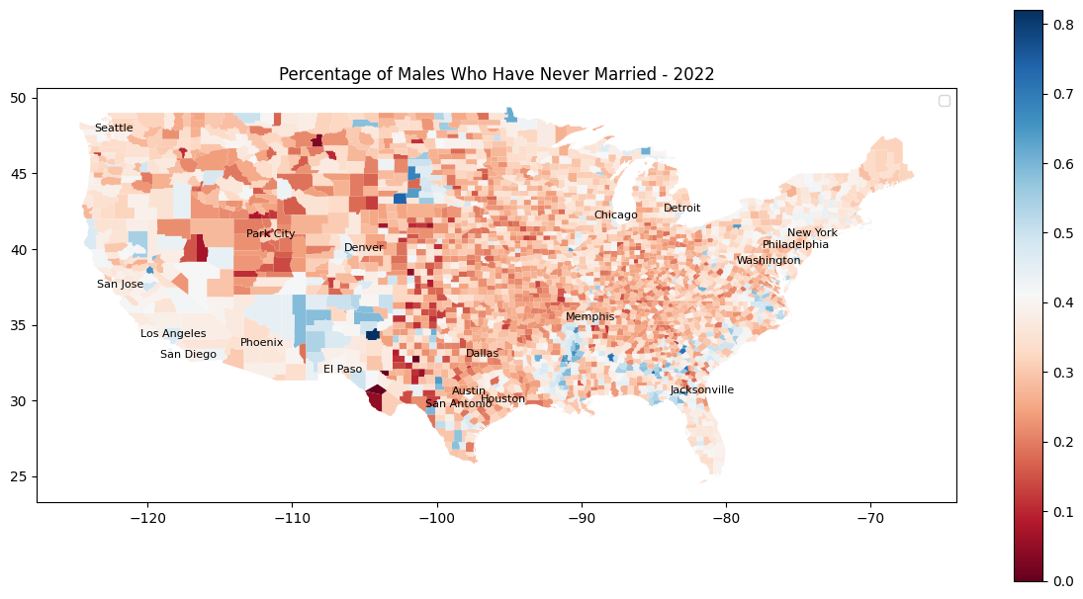

Subgroup Analysis
To create racial subgroups, the counties were chosen and aggregated if they had over 5% more than the national average of each minority race. These averages are shown in table 5.

Table 5
Racial Demographics Descriptive Statistics
 | count | mean | std | min | 25% | 50% | 75% | max
PERC_WHITE | 3135 | 81.76 | 16.95 | 3.30 | 74.61 | 88.10 | 94.10 | 100.00
PERC_BLACK | 3135 | 9.03 | 14.46 | 0.00 | 0.68 | 2.26 | 10.09 | 87.78
PERC_ASIAN | 3135 | 1.41 | 2.86 | 0.00 | 0.29 | 0.64 | 1.33 | 42.60
PERC_NAT_HAW | 3135 | 0.12 | 1.19 | 0.00 | 0.00 | 0.01 | 0.07 | 62.20
PERC_AM_IND | 3135 | 1.96 | 7.74 | 0.00 | 0.15 | 0.33 | 0.84 | 94.54
PERC_TWO_RACE | 3135 | 3.52 | 2.58 | 0.00 | 1.90 | 2.86 | 4.37 | 29.51
PERC_OTHER | 3135 | 2.21 | 3.82 | 0.00 | 0.40 | 1.04 | 2.50 | 54.70
PERC_HISP_LAT | 3135 | 9.58 | 13.92 | 0.00 | 2.31 | 4.37 | 9.96 | 98.91

Figure 3 shows that counties with more Black, Latino, and Native men than average have lower bachelor’s degree attainment, higher poverty. Counties with more Asian men have higher degree attainment and less poverty. All of the counties with above average proportions of racial minorities have lower marriage rates.

Figure 3
Disadvantage Metrics in Racial Minority Communities
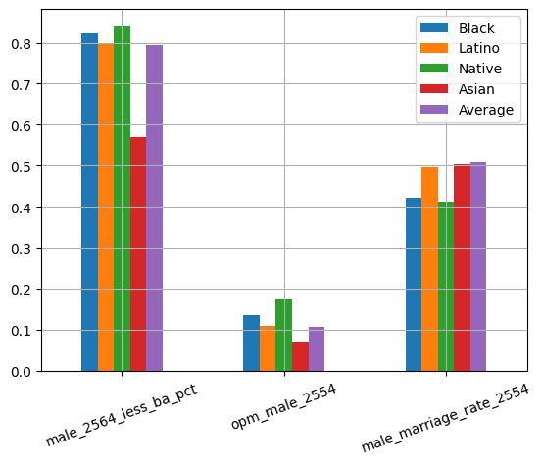

Unsupervised Predictions - County Clustering
K-means clustering uses all the features to group the observations into clusters. Then I will look at the cluster results to see their features and how they relate to disadvantage.
This model used the combined demographic, economic, housing, and Area Disadvantage Index values as features. This was 104 features total.
The K-means clustering algorithm created 4 clusters using the socioeconomic features supplied. These clusters are shown in map 10.

Map 10
Cluster Map
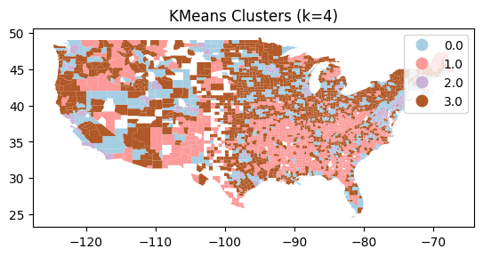

As show in table 6, cluster 1 has the highest percentage of males with no bachelor’s degree and males in poverty. Cluster 2 has the highest marriage rates.

Table 6
Cluster Means of Disadvantage Metrics
cluster | male_2564_less_ba_pct | opm_male_2554 | male_marriage_rate_2554
0 | 0.716 | 0.073 | 0.550
1 | 0.867 | 0.156 | 0.460
2 | 0.562 | 0.049 | 0.575
3 | 0.809 | 0.099 | 0.518

Supervised Predictions – Random Forest
The last element of this analysis is using a random forest classification model to predict the target disadvantage variables using the 103 feature socioeconomic dataset.

Educational Attainment
The most important features for predict the rate of bachelor’s degree attainment is the occupation “Management, Business, Science, and Arts Occupations”, per capita income, the occupation “Natural Resources, Construction, and Maintenance Occupations”, the industry “Professional, Scientific, and Management, and Administrative, and Waste Management Services” and ADI National Rank. The linear relationships with the top 5 features are shown in figure 4.

Table 7
Bachelors Degree Random Forest Model Attainment Feature Importance
Feature | Importance
occ_man_bus_sci_arts | 0.6156
per_capita_income | 0.0533
occ_nat_con_maint | 0.0340
ind_prof_sci_man_admin | 0.0322
ADI_NATRANK_2022 | 0.0299
PERC_ASIAN | 0.0202
Median_rent | 0.0201
ind_ag_for_fish | 0.0134
employed | 0.0116
mean_household_income | 0.0104

Figure 4
Important Features vs Bachelor’s Degree Attainment
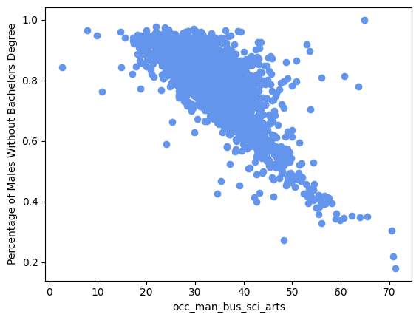 | 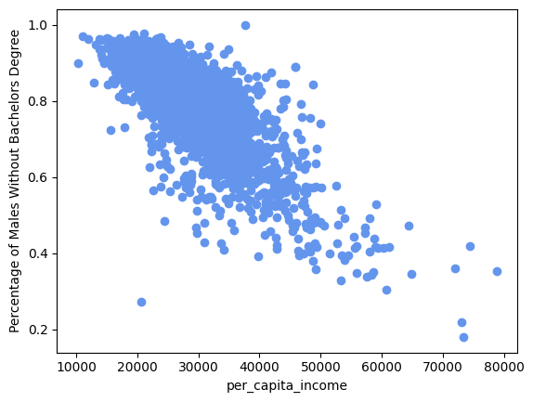
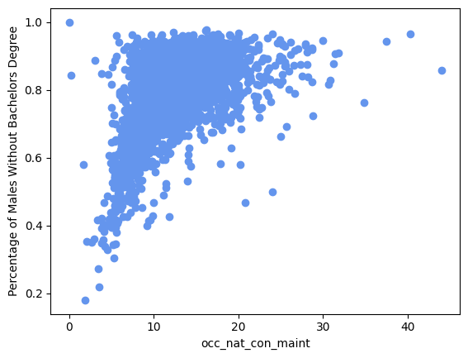 | 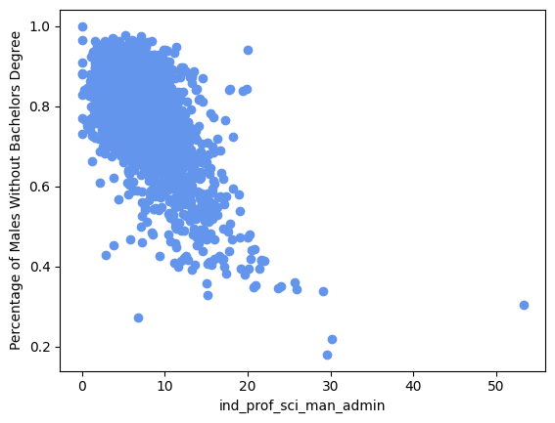
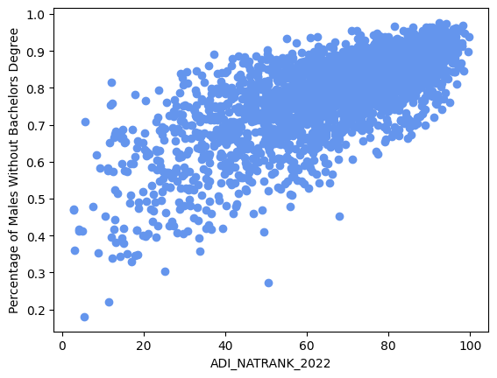

Poverty
The most important features for predicting the poverty rate of adult men are the adult poverty rate, having public healthcare, having private healthcare, and family poverty. The linear relationships with the top 5 features are shown in figure 5.

Table 8
Poverty Rate Random Forest Model Feature Importance
Feature | Importance
poverty_adults | 0.5481
public_health | 0.0292
private_health | 0.0273
poverty_all_families | 0.0271
poverty_children_families | 0.0145
mean_household_income | 0.0110
median_household_income | 0.0109
employed | 0.0102
class_priv_salary | 0.0094
perc_snap | 0.0088

Figure 5
Important Feature vs Poverty Rate
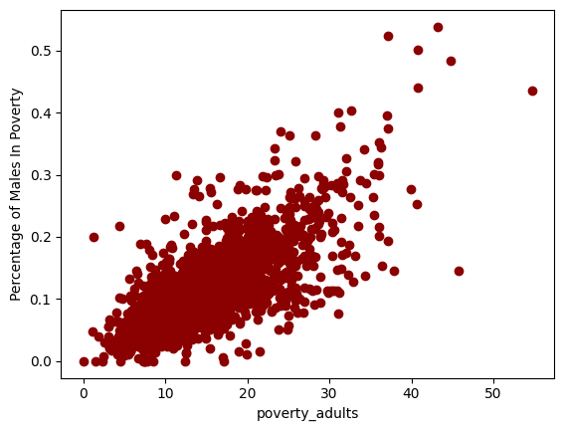 | 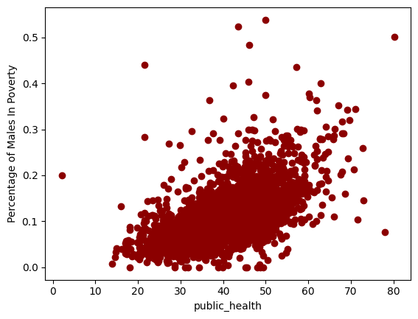
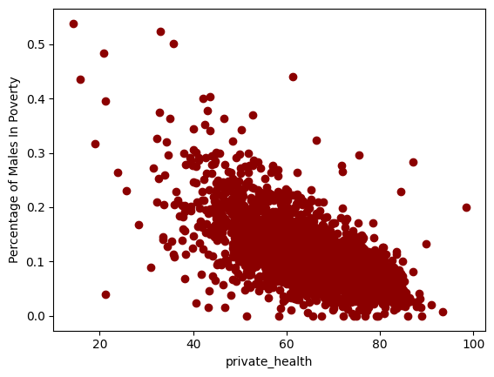 | 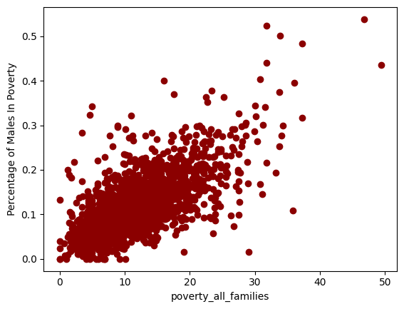
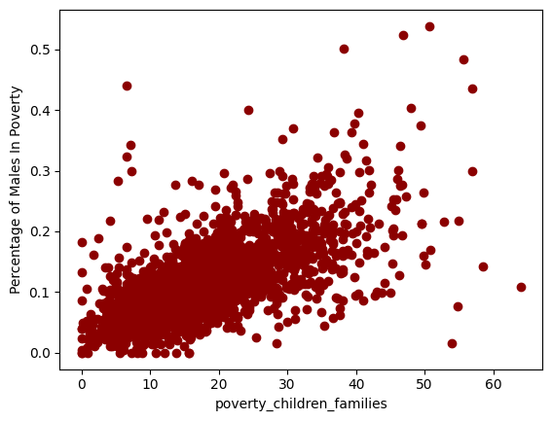

Marriage Rate
The most important features in predicting the marriage rate is the ratio of men to women, vehicles available in the household, employment, percent white, and having public healthcare. The linear relationships with the top 5 features are shown in figure 6.

Table 9
Marriage Rate Random Forest Model Feature Importance

Feature | Importance
GENDER_RATIO | 0.187
VEHICLES AVAILABLE!!Occupied housing units!!1 vehicle available_Percent | 0.167
employed | 0.100
PERC_WHITE | 0.099
public_health | 0.036
perc_snap | 0.020
MALE_PERC | 0.020
FEMALE_PERC | 0.015
VEHICLES AVAILABLE!!Occupied housing units!!No vehicles available_Percent | 0.015
labor_force | 0.014

Figure 6
Important Feature vs Marriage Rate
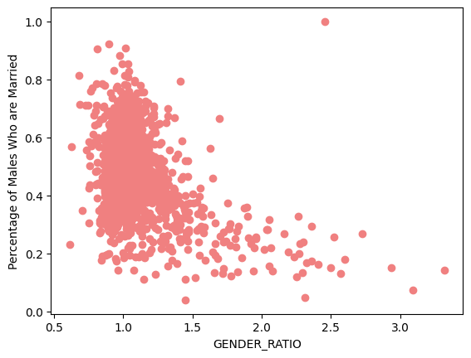 | 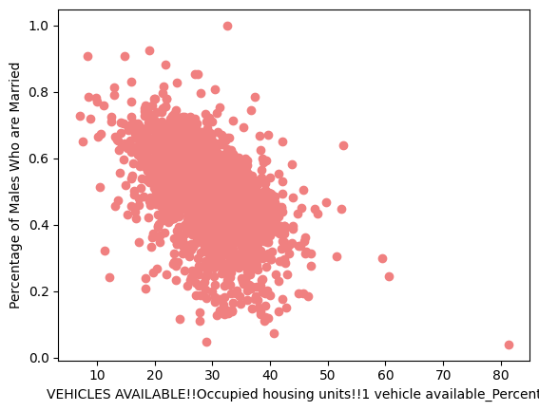
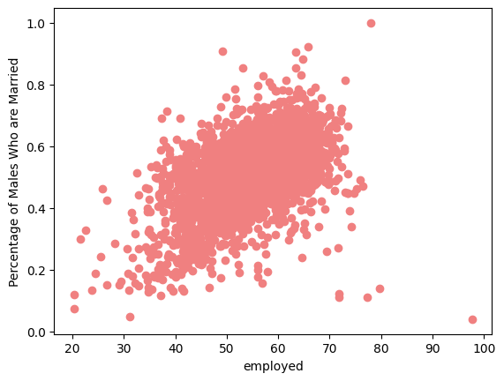 | 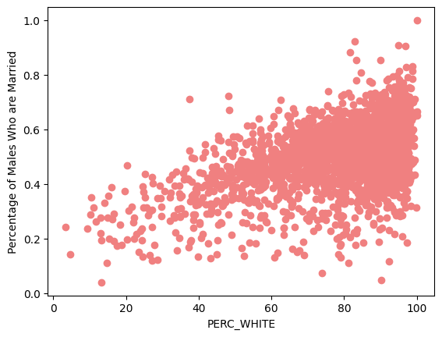
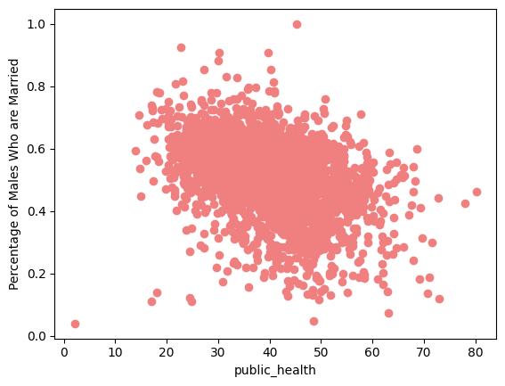

Discussion
This analysis initially finds that in 2022, the 79.4% of adult men in America do not have a bachelor’s degree. 6.8% are living below the poverty line, and a little over 50% are married. The high rate of bachelor’s non-attainment does not bode well for the economic prospects of a large portion of the population, considering that the cost of living is outpacing wages. A lack of degree had made career advancement increasingly difficult and that is the reality that many men are dealing with.
The greatest number of disadvantaged males live in California, Nevada, Arizona, Illinois, and Texas. State level actions in these states have the potential to impact the largest number of people. While less populated states have a higher severity of disadvantage. Federal intervention that is pulled from a National tax base has the potential to have a high return on investment for less populated states with high degrees of disadvantage.
States in the southwest, deep south, Wyoming, and West Virginia appear to have the highest rates of disadvantage even though their populations aren’t very dense. These are more rural, less developed states that are likely losing jobs to globalization and losing people to brain drain.
At the county level, bachelor’s degree attainment is highest near cities and lowest in the Southwest and rural areas. Poverty is highest in the counties around New Mexico, South Dakota, and in the Appalachian Region. Marriage is lowest is the western midwest, around Utah, and in southwest Texas.
The subgroup analysis found that counties with more people of color have higher means for the all three disadvantage metrics.
In the clustering analysis, the clusters mirrored some of the disadvantage maps, with cluster 2 surrounding major cities and cluster 1 appearing in impoverished rural areas.
Lastly, in the random forest models gave insight into some strong linear relationships between socioeconomic characteristics and the disadvantage metrics. It was found that increase percentages of professional occupations and industries predicted an increase in bachelor’s attainment, while higher natural resource, construction, and maintenance occupations predicted less bachelor’s attainment.
The poverty rate random forest model showed the clear relationship between adult and family poverty with adult male poverty. However, it also uncovered that a higher percentage of people on public health insurance predicts higher poverty and private health insurance predicts lower.
The marriage rate random forest model uncovered positive relationships between marriage rate and percentage white and percentage employed. Then there were negative relationships with only have 1 vehicle, a having more men than women, and higher rates of public health insurance.
These findings are fairly straightforward, but the methodology of this analysis provides an entry into the topic. Additionally, the supervised and unsupervised machine learning techniques utilized in the second half demonstrate a novel procedure for identifying areas of disadvantage for further investigation.

References
Kind AJH, Buckingham W. Making Neighborhood Disadvantage Metrics Accessible: The
Neighborhood Atlas. New England Journal of Medicine, 2018. 378: 2456-2458. DOI: 10.1056/NEJMp1802313. PMCID: PMC6051533.

University of Wisconsin School of Medicine and Public Health. 2022 Area Deprivation
Index v4.0. Downloaded from https://www.neighborhoodatlas.medicine.wisc.edu/ December 10, 2024.

U.S. Census Bureau. (2020). ACS DEMOGRAPHIC AND HOUSING ESTIMATES. *American
Community Survey, ACS 5-Year Estimates Data Profiles, Table DP05*. Retrieved December 18, 2024, from https://data.census.gov/table/ACSDP5Y2020.DP05?g=010XX00US$0500000&moe=false&tp=true.>

U.S. Census Bureau. (2020). SELECTED ECONOMIC CHARACTERISTICS. American
Community Survey, ACS 5-Year Estimates Data Profiles, Table DP03. Retrieved December 18, 2024, from https://data.census.gov/table/ACSDP5Y2020.DP03?q=select economic.

U.S. Census Bureau. (2022). Selected Housing Characteristics. *American Community Survey,
ACS 5-Year Estimates Data Profiles, Table DP04*. Retrieved December 19, 2024, from <https://data.census.gov/table/ACSDP5Y2022.DP04?q=rent&t=Owner/Renter> (Householder) Characteristics&g=010XX00US$0500000&moe=false&tp=true.

U.S. Census Bureau. "Poverty Status in the Past 12 Months by Sex by Age." *American
Community Survey, ACS 5-Year Estimates Detailed Tables, Table B17001*, 2022, <https://data.census.gov/table/ACSDT5Y2022.B17001?q=b17001&g=010XX00US$0500000>. Accessed on December 18, 2024.

U.S. Census Bureau, U.S. Department of Commerce. (2023). Sex by Marital Status for the
Population 15 Years and Over. *American Community Survey, ACS 1-Year Estimates Detailed Tables, Table B12001*. Retrieved December 18, 2024, from <https://data.census.gov/table/ACSDT1Y2023.B12001?q=B12001:> Sex by Marital Status for the Population 15 Years and Over&g=010XX00US$0500000.

U.S. Census Bureau. (2021). SEX BY AGE BY EDUCATIONAL ATTAINMENT FOR THE
POPULATION 18 YEARS AND OVER. *American Community Survey, ACS 1-Year Estimates Detailed Tables, Table B15001*. Retrieved December 18, 2024, from <https://data.census.gov/table/ACSDT1Y2021.B15001?q=B15001:> SEX BY AGE BY EDUCATIONAL ATTAINMENT FOR THE POPULATION 18 YEARS AND OVER.

Appendix

Appendix 1
Full Descriptive Statistics
index | count | mean | std | min | 25% | 50% | 75% | max
male_25_64_tot | 3144 | 27420.6 | 90477.1 | 16.0 | 2721.0 | 6593.5 | 17477.5 | 2773528.0
male_2564_less_ba | 3144 | 18325.7 | 57439.8 | 16.0 | 2285.8 | 5434.0 | 13633.5 | 1838364.0
male_2564_less_ba_pct | 3144 | 0.794 | 0.109 | 0.180 | 0.747 | 0.821 | 0.869 | 1.000
pop_county_male | 3144 | 20303.4 | 69979.3 | 8.0 | 1790.0 | 4461.5 | 12188.8 | 2158883.0
pop_opm_county_male | 3144 | 1757.9 | 6329.4 | 0.0 | 184.8 | 486.5 | 1231.5 | 210949.0
opm_male | 3144 | 0.108 | 0.057 | 0.000 | 0.068 | 0.098 | 0.134 | 0.538
pop_county_male_mar | 3144 | 10364.2 | 32571.0 | 1.0 | 956.8 | 2351.0 | 6533.8 | 885889.0
pop_county_male_never_mar | 3144 | 7462.7 | 29645.3 | 0.0 | 573.8 | 1485.0 | 4211.3 | 1022585.0
pop_county_male_separated | 3144 | 384.1 | 1342.4 | 0.0 | 28.0 | 100.0 | 276.3 | 42964.0
pop_county_male_other | 3144 | 660.7 | 2898.8 | 0.0 | 39.0 | 128.0 | 371.3 | 100373.0
pop_county_male_widowed | 3144 | 95.5 | 275.3 | 0.0 | 5.0 | 26.0 | 80.0 | 7239.0
pop_county_male_divorced | 3144 | 1814.8 | 4926.2 | 0.0 | 221.0 | 584.5 | 1464.3 | 118273.0
male_marriage_rate | 3144 | 0.511 | 0.111 | 0.040 | 0.456 | 0.523 | 0.579 | 1.000
perc_never_married | 3144 | 0.319 | 0.094 | 0.000 | 0.257 | 0.310 | 0.369 | 0.920

